**Effect of Learning Curve in Transradial Approach to Coronary Angiography and Percutaneous Intervention**

**Saad Mahmood Zaidan** (MBChB, FICMS)1 **,**  **Ammar Zaidan Ammran** (MBChB, FICMS)2 **and Zakariya Jubran Khaleel**  (MBChB, MSc)3

**Abstract**

**Background:** TR approach is suitable for most patient and limitations is very low. It become more popular and approved in international guidelines because of increase success rate and low complication rate and low cost. There is also parallel advancement in instruments used in TR approach.

**Objective:** To establish the rule of learning curve in transradial approach to CA and PCI and encourage the operator for doing more transradial catheterization.

**Patients and Methods:** Patients admitted for CA or PCI. Data collected from patient and procedure including age, sex, contrast volume, total procedure time. flouro time, radial artery spasm and number of cases that transformed to femoral. We divided the study in two groups: group A first half of patient and group B the second half.

**Results:** Total numbers of patients (139) and there age ranging from 28 to 80 years (mean of 55.13). Number of males 131 (94.2%) and females 8 (5.7%).The mean value of contrast volume used in group A that underwent CA, ad hoc and PCI ,(was 63.10,124.20 and 106.91 ml) respectively and for group B (50.07,88.19 and 49.56 ml).The mean total time of procedure of group A underwent CA, ad hoc and PCI was (17.16,24.9 and 26.13 minutes) respectively and for group B(13.66,26.3 and 16.4 minutes).The mean fluorotime of group A underwent CA, ad hoc and PCI was (4.61,7.2 and 6.62 minutes) and for group B (3.06,7.32 and 3.51 minutes ). Seventeen case subjected to radial artery spasms divided into 11 cases (15.7%) in group A and 6 cases (8.69 %) in group B. There were 8 cases (11.4 %) of group A transferred to femoral approach and 4 cases (5.79 %) of group B transferred to femoral access.

**Conclusion:** There was much benefit from the effect of learning curve in doing TR approach to CA and PCI.

**Keywords:** TR approach, CA, PCI, fluorotime.

**Corresponding Author:** ammarrashed75@yahoo.com

**Received:**  19th  June 2019

**Accepted:** 27h June 2019

**DOI:https://doi.org/10.26505/DJM.18014750619**

1,2,3 Interventional Cardiology Department - Baquba Teaching Hospital - Ministry of Health - Diyala -Iraq.

**Introduction**

**Anatomical consideration:** Anatomy of the femoral, brachial and radial arteries is important and of benefit for getting arterial access and doing these techniques successfully[1].

**Femoral access:** Common femoral artery(CFA) is the extension of external iliac artery. It start below the inguinal ligament. CFA and vein covered by a fibrous sheath that has been named femoral sheath. TF approach associated with more complication due to its proximity to the femoral nerve, femoral vein and pelvic cavity. Because puncturing of superficial femoral artery is more susceptible to pseudoaneurysm, CFA the first three centimeters must be chosen for arterial puncture[2].

**Radial access:** The radial artery (RA) is the extension of the brachial artery. It starts at the bifurcation of the brachial artery in the cubital fossa, and runs along the radial side of the forearm to the wrist toward the styloid process of the radius [1]. After that it passes between the two heads of the first Interosseousdorsalis into the palm of the hand. At the wrist where arterial puncture should be done there is no nerve, vein or cavity at the vicinity of the RA,,The RA serves mainly as an arterial conduit to the hand [6].

Radial access was associated with less complication regarding access site bleeding, vascular complications, and need for transfusion. There was a significant mortality benefit in patients with the transradial access site [4].

|  |  |  |
| --- | --- | --- |
| Radial access is recommended over femoral access if performed by an experienced radial operator | I | A |

**Figure (1)** Procedural aspects of the primary percutaneous coronary intervention strategy according to 2017 ESC guidelines for the management of AMI

**Patients and Methods**

The study population was drawn from 139 patients admitted to (cathetrization department in BaqubaTeaching Hospital , Diyala , Iraq) for CA & PCI between February 2017 and August 2017. Written informed consent was obtained from every patient. All patients who underwent the TR approach had Barbuae test(3,4,8)If the test suggested incomplete palmer arch flow, the TR approach was deferred and transferred to TF access.

The study group included patients who underwent CA & PCI for stable angina, post

revascularisation angina and for assessment of coronary anatomy before valvular surgery and for early invasive strategy for high risk unstable angina. All patients were prepared according to the American College of Cardiology/American Heart Association (AHA/ACC) task force on Cardiac Catheterization. Patients at high risk for contrast induced allergic reaction had premedications by IV hydrocortisone. Routine laboratory investigations including blood urea ,serum creatinine, viral screen includes human immune deficiency virus (HIV),hepatitis B surface antigen (HBS Ag) and hepatitis C virus (HCV) antibody. The patient was placed in a decubitus supine position with the arm along the side of the body.

Under local anesthetic (xylocaine 1%), we performed the puncture with a 21-gauge needle or plastic canulla and then introduced a straight 0.021-inch guide catheter, followed by the introduction of a 6 F 11-cm introductory catheter (Transradial Kit, Cordis Corp, Miami, Fl., USA). All patients took 3000 units of heparin with a spasmolytic 150 μg nitroglycerine) via the lateral catheter before the procedure was begun; this cocktail was readministered in case the patient suffer of forearm pain or if there was resistance to catheters manipulation. The introductory catheter was changed with a 0.035-inch angiography guide up to the ascending aorta, and then the radiography-controlled catheters were inserted.

The choice of catheters was depend on planned procedure. After finishing of procedure the sheath remove immediately and access site secured by manual compression or some time with hemostatic band. The bandage was kept in place for at least 4 hours. The patient was allowed to be ambulatory immediately following the procedure All patients were evaluated (4-24 hours) after the procedure and we noted the presence of palpable hematoma at the access site, pain on palpation of the access site, and the presence of a distal radial pulse.

For each patient we gathered the data from the procedure: total length of time for the procedure, fluoroscopy time, contrast material volume, crossover to TF approach, incidence of spasm, subcalvian artery tortuisty. So as to determine the impact of the learning curve, we divided the study population into 2 groups: group A was the first 70 patients on whom the procedure was performed and group B the second 69 patients. Exclusion criteria:

1-abnormal Barbuae test

2-weak thread radial pulse

3-the existence of a known arterial circulatory disease in one of the upper limbs

4-prior CABG

5-extreme anxious patient

**Statistical analysis**

Data of the patients were entered and analyzed by using the statistical package for social sciences (SPSS) version 21, IBM, US, 2014. Descriptive statistics were presented as mean, standard deviation (SD) for continuous variables and as, frequencies (No.) and percentages (%) for categorical variables.

Student’s test (independent two groups type) was carried out to detect the differences, if any, between two means. Similarly, Chi square and Fisher’s exact test were used alternatively, to detect differences in categorical variables in the same groups., odds ratio was calculated to estimate the higher risk group .

Level of significance (P.value) <0.05 considered significant. Level of significance (P.value) <0.01considered highly significant. Finally results and findings were presented in tables and figures with explanatory paragraphs.

**Results**

Study done in 139 patients with age range from 28 to 80 years, giving to a mean of 55.13.Gender distribution were male 131 (94.2%) and female 8 (5.7%) as shown in table and figure, Cases divided into groups with group A first 70 cases (50.4%) and group B second 69 (49.6%),and each group is further divided according to procedure into CA,AD HOC,PCI. The mean of contrast volume that used with group A that underwent CA was 63.10 ml while mean value of contrast volume used in group B that underwent CA was 50.07 ml, and there was significant p value (P value= 0.029).The mean value of contrast volume used with group A that underwent ad hoc about 124.2 ml while mean value of contrast volume used in group B that underwent ad hoc was 88.19 ml, there was highly significant p value (P value=0.004).The mean value of contrast volume used in group A that underwent PCI about 106.9 ml while mean value of contrast volume used in group B that underwent PCI was 49.6 ml ,and there was highly significant p value (P value= 0.0003).as shown in table 2 that show contrast volumes used in Group A and B in CA, ad hoc and PCI.

The mean total time of procedure of A underwent CA was seventeen minutes whereas mean total time of procedure of group B underwent CA was thirteen minutes, and there was extremely important p value (P value=0.015).The mean total time of procedure of A underwent adhoc was twenty four minutes, whereas mean total time of procedure of group B underwent adhoc was

twenty six minutes, and there was no important p value (P value=0.45).The mean total time of procedure of A underwent PCI was twenty six minutes ,while mean total time of procedure of group B underwent PCI was sixteen minutes ,and there was extremely important p worth (P value=0.01) as shown in table three that show total time spent within the whole procedure in A and B in CA, adhoc and PCI.

Group A underwent CA mean florou time was four. sixty one minutes, whereas group B underwent CA mean fluoro time was three. six minutes ,there was high important p (P value=0.005). group A underwent ad-hoc mean fluoro time was seven. two minutes, whereas group B underwent ad-hoc mean fluoro time was seven. thirty two minutes ,there was no important p (P value=0.91). group A underwent PCI mean fluoro time was half six. sixty two minutes, whereas group B underwent primary coronary intervention mean fluoro time was three. fiftyone minutes,there was important p (P value=0.035) as shown in table four that show X-ray machine time that spent in group A and B in CA, ad hoc and PCI. The incidence of radial artery spasms were about 17 cases ( 12.23%) in both group,11 cases (15.7%) in group A and 6 cases (8.69 %) in group B. There were about 9 cases (6.47 %) with severe tortuosity, 5 cases (3.59 %) with moderate tortuosity and 4 cases (2.87 %) with mild tortuosity. There were 8 cases (11.4 %) of group A transferred to femoral approach and 4 cases (5.79 %) of group B transferred to femoral access.

**Table (1):** Gender distribution

| NO (%) | Gender |
| --- | --- |
| 131 (94.2) | Male |
| 8 (5.7) | Female |

**Table (2):** Distribution of contrast volume used in Group A and B

| Mean | Procedure | Group |
| --- | --- | --- |
| 63.10 | CA | Group A |
| 124.10 | AD HOC |  |
| 106.91 | PCI |  |
| 50.07 | CA | Group B |
| 88.19 | AD HOC |  |
| 49.56 | PCI |  |

**Table (3):** Distribution of total time of procedure in Group A and B

| Mean | Procedure | Group |
| --- | --- | --- |
| 17.16 | CA | Group A |
| 24.9 | AD HOC |  |
| 26.13 | PCI |  |
| 13.66 | CA | Group B |
| 26.3 | AD HOC |  |
| 16.4 | PCI |  |

**Table (4):** Distribution of fluoro time in group A and B

| Group | Procedure | Mean |
| --- | --- | --- |
| Group A | CA | 4.61 |
|  | AD HOC | 7.2 |
|  | PCI | 6.62 |
| Group B | CA | 3.06 |
|  | AD HOC | 7.32 |
|  | PCI | 3.51 |

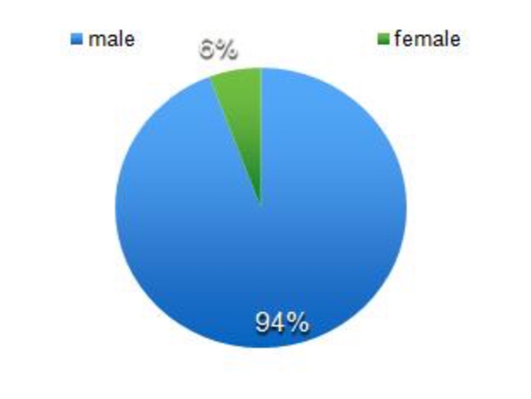

**Figure (2):** Gender distribution

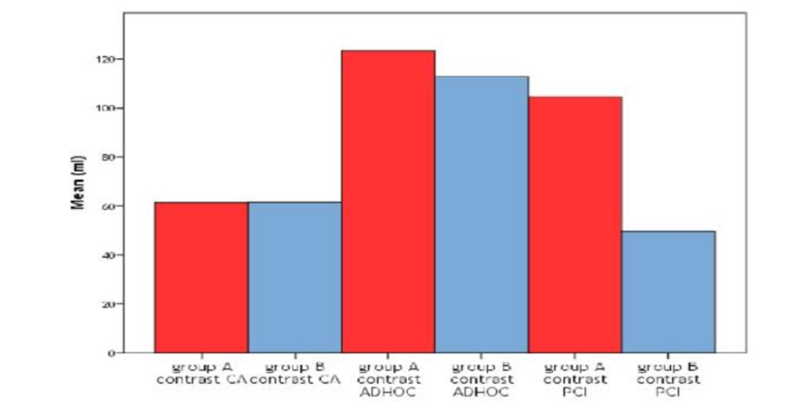

**Figure (3) :**Show contrast volume that used in group A and B that underwent CA, AD HOC and PC

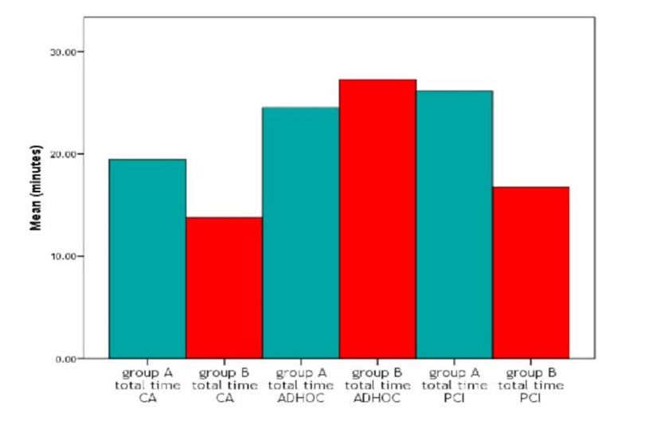

**Figure (4):** Show total time of procedure of group A and B that underwent CA,AD HOC and PCI

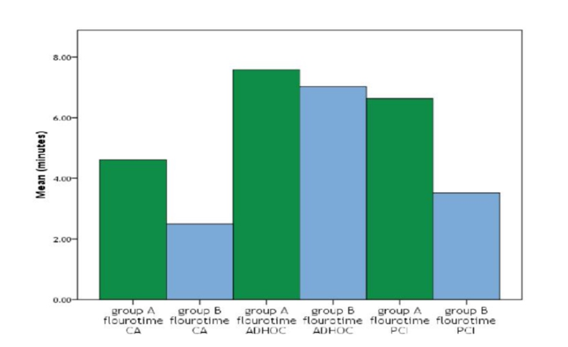

**Figure (5):** Show duration of fluoro time that used of group A and B that underwent CA, AD HOC and PCI

**Discussion**

The mean age of our study was fifty five, and it contemplate as low mean age for the incidence of ischaemic heart condition as compared with the western countries ,while in study of Ruzsa et al,. mean age was higher (68minus plus 8)[9].Also study of Warren et al,. show higher mean more matured (62 minus plus 11) [9].This is might be explained by referral of young age to coronary angio in our community, additionally older age not settle for to be observed coronary roentgenography, additionally might be

thanks to inadequate fortification in our community. In this study, gender distribution were male ninety four% and female was five%,if we have a tendency to compare this result with study of Warren et al,. that show very little distinction in gender distribution of male (81%) and female (19%) [9] however study of Ruzsa et al,[9] .Take issue in gender distribution as male sixty seven and female thirty third. The male predominancy in IHD

goes with international information however the female share in our study is less than share of alternative studies and this might be explained by anxiety and smaller arteries, in females and consequently less transradial approach select in females. Mean volume of distinction that utilized in A that underwent CA, adhoc and PCI higher that of type B that underwent CA, adhoc and PCI severally, there have been important P value, this can be might be explained like time there's a lot of impact of learning curve in TR approach like time less numbers of catheter required to finish the procedure and straightforward with correct engagement of coronary Ostia.

The mean total time of procedure of group A longer in length than of group B that underwent CA and PCI. And show extremely P significant.

This could be explained additionally by learning curve expertise with the time, as less access site problem, less spasm, straightforward engagement, with additional cases result in additional expertise in doing procedure in less time, and this is often accept as true with study of Fernandez et al,, as show less time of procedure would like in group B[10]. But the mean solar time of group B less in length than group a that underwent adhoc and no P significant . This is attributed partly to percentage of complex cases in group B including dealing with total occlusion lesion or complex PCI needed more than one balloon and stent and in some cases treating more than one artery in one stage and in some cases severe subclavian artery tortuousity, and this is disagree with study of Fernandez et al,, as show less time of procedure need in group B underwent ad hoc[10]. The mean fluorotime time needed in group B less than of group A that underwent CA and PCI and show significant P value and this is again agree with study of Fernandez et al,, as show less time of fluoro time need in group B as this is approve learning curve in transradial approach [10]. The mean fluoro time needed in cases underwent AD HOC procedure show non significant P value and this is can be explained earlier by complicity of cases in group B in AD HOC cases.

There was obvious reduction in range of cases that transferred to TF approach between blood group A and B, this due to numerous reasons together with problem in obtaining the access, decrease arterial blood vessel spasm, uncrossable severe artery tortuousness, or inability to reach left, right or each coronary Ostia engagement. This is additionally support the impact of learning curve in TR approach.

**Conclusions**

The TR approach is a good choice for doing coronary catheterization and there was much benefit from the effect of learning curve in doing the procedures.

**Recommendation**

1-We encourage TR approach in doing coronary catheterization.

2-We suggest further studies with more number of cases and more parameters to investigate.

3-We encourage primitive operator to enter in learning curve

**References**

[1]Rander S. Thoracal aortography by catheterization from radial artery; preliminary re‐port of a new technique. Acta Radiol 1948; 29: 178-80.

[2]Campeau L. Percutaneous radial artery approach for coronary angiography. Cathet Cardiovasc Diagn 1989; 16: 3-7.

[3]Benit E, Vranckx P, Jaspers L, Jackmaer TR, Poelmans C, Coninx R. Frequency of a positive modified Allen’s test in 1000 consecutive patients undergoing cardiac cathe‐terization. Cathet Cardiovasc Diagn 1996; 38: 352-4.

[4]Barbeau G, Arcenault F, Dugas L, Lariviere M. A new and objective method for transradial approach screening. J Am Coll Cardiol 2001; 37: 34A-36A.

[5]Karlsson S, Neichajev IA. Arterial anatomy of the upper extremity. Acta Radiol Diagn 1982; 23: 115-2.

[6]Haerle M, Hafner HM, Dietz K, Schaller HE, Brunelli F. Vascular dominance in the forearm. Plast Reconstr Surg 2003;111: 1891-8.

[7]Fernández SJ, Santos SC, Rodríguez JM, González VN, Rey EV, Fernández RP, Zubeldía BB and Beiras CA. Transradial Approach to Coronary Angiography and Angioplasty: Initial Experience and Learning Curve.Rev Esp Cardiol. 2003;56:152-9 .

[8]Campeau L. Percutaneous radial artery approach for coronary angiography. Cathet Cardiovasc Diagn. 1989; 16:3–7. [9]Jolly SS, Yusuf S, Cairns J, Niemela K, Xavier D,

Widimsky P, Budaj A, Niemela M, Valentin V, Lewis BS, Avezum A, Steg PG, Rao SV, Gao P, Afzal R, Joyner CD, Chrolavicius S, Mehta SR, RIVAL Trial Group. Radial versus femoral access for coronary angiography and intervention in patients with acute coronary syndromes (RIVAL): a randomised, parallel group, multicentre trial.Lancet 2011; 377(9775):1409–1420. [10]Romagnoli E, Biondi-Zoccai G, Sciahbasi A, Politi L, Rigattieri S, Pendenza G, Summaria F, Patrizi R, Borghi A, Di Russo C, Moretti C, Agostoni P, Loschiavo P, Lioy E, Sheiban I, Sangiorgi G. Radial versus femoralrandomized investigation in ST-segment elevation acute coronary syndrome: the RIFLE-STEACS (Radial Versus Femoral Randomized Investigation in ST-Elevation Acute Coronary Syndrome) study. J Am Coll Cardiol2012;60(24):2481–2489.